**Changing a timetable in a session file whilst retaining routes**

There is no method within Railway Operation Simulator (ROS) to save a railway containing routes and then load a new timetable. This isn't normally a problem because automatic signal routes can be reset within a minute or two after a new timetable is loaded into a railway without routes. It is a problem however with very big railways like Krizar's London Underground, when automatic signal route setting can take a long time.

To get round this restriction session files can be manipulated directly, by temporarily saving all the routes and associated track etc, creating a new session file without routes but containing a new edited timetable, then inserting the routes and track back into this new session file. BUT, very importantly, a normal text editor such as Notepad or Wordpad can't be used, because all ROS files contain NULL characters (code '0' in ASCII), and normal text editors ignore these characters. Therefore Notepad++ (available from https://notepad-plus-plus.org/) is recommended. It is a free code editor that doesn't itself make any changes to loaded files.

The following detailed description sounds very complicated but after a time or two it should become quite intuitive and therefore reasonably quick. Using Krizar's railway as an example, load the railway in ROS as normal, then edit the timetable that came with it. When the new timetable is as required and validates successfully save it, reload it, select 'Operate' and immediately save a session file without any routes.

Now load the original session file (TFL_Sunday_0630_0730_Session.ssn) into Notepad++ (or another suitable editor if you prefer - bearing in mind what was said earlier about text editors), and also load the new session file that you just saved. These will both load in Notepad++ under their own tabs.

**Very important: remember which is which!!**

Click the original session file tab (TFL_Sunday_0630_0730_Session.ssn) and scroll down to the timetable section which begins at line 388153. Now select everything up to line 388152 inclusive as described below so it can be inserted into the new session file.

This is what the start of the file and the timetable section look like in Notepad++:-

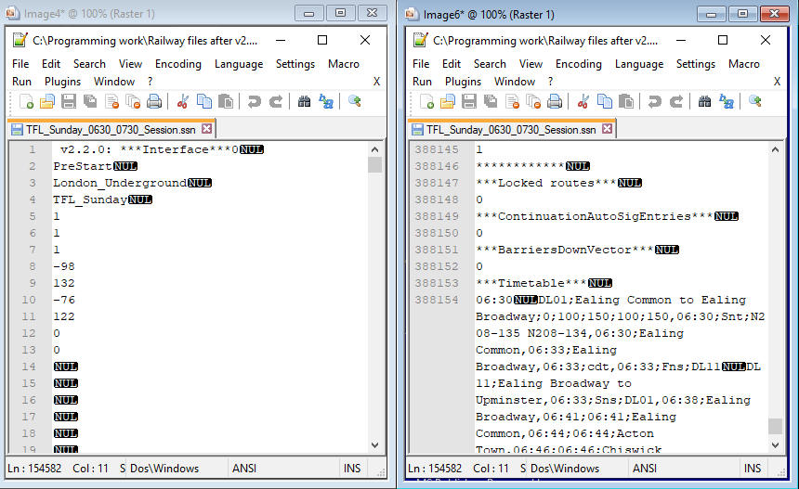

To find quickly the start of the timetable section hold the Ctrl key down and press 'f'. This brings up the search screen. Enter 'timetable' and press 'Enter'. This will find the timetable start line which is 388153 - '***Timetable***NUL'. Click the left mouse button at the start of this line then hold down Ctrl and Shift together and press Home. This will select everything before the timetable section.

Now, click 'Edit', 'Paste Special' (this no doubt sounds inappropriate as we want to copy, not paste, but Notepad++ uses this for copying the content as it is rather than as text), then 'Copy Binary Content'. Click 'File' then 'New', then 'Edit', 'Paste Special' and 'Paste Binary Content', and the selected text should be pasted (with all the necessary NULLs) into this new file. Check it begins with the version number, ends with '***BarriersDownVector*** NUL' followed by a zero, and is 388152 lines long.

All good? Great!

Now save it as it will probably be needed later on for future timetable changes. **But don't save as 'Normal text file (*.txt)' or the NULLs will be lost, select 'All types (*.*)' and give it a name that doesn't end in .txt.**

Now go to the new session file you saved with no routes, and go to the line '***Timetable***NUL' using the search function as before. This will now be at line 293145 as shown below:-

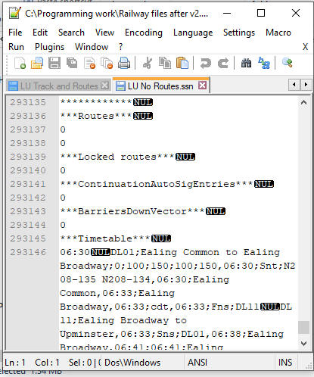

Left click the mouse at the start of line 293145, press Ctrl, Shift and Home, and everything above the timetable section should be selected as before. Press 'Del' as we don't need this section. Now paste the earlier saved section - left click the mouse at the start of the file, i.e. the start of line 1, which contains '***Timetable***NUL'. Now go back to the saved track and routes file (here called 'LU Track and Routes') by clicking its tab, then 'Edit', 'Select All', 'Edit', 'Paste Special', 'Copy Binary Content', then return to the session file with no routes by clicking its tab, and the cursor should still be at the start of the file. Click 'Edit', 'Paste Special' and 'Paste Binary Content' and the earlier track and routes should now be before the timetable section, which should now be at line 388153 - as before. Now click 'File' and 'Save As', and give the revised session file an appropriate name, keeping .ssn at the end.

If all has gone well this should load satisfactorily into the program, and you now have a new timetable with all the routes as originally set.

Note that the session file loader is very unforgiving. A wrong line or a missing NULL and it won't load, and it won't be obvious why it hasn't. Be sure therefore to follow the above steps accurately.

Note also that this method won't work for a railway where trains have been moving, because the signal aspects won't match the new timetable for which trains haven't started to move.

If you have any problems please post any offending files on Discord in the feature-requests channel and I'll try to help. Also if you notice anything wrong in this note please let me know and I'll correct it - thanks.

Albert

12 January 2020